Extra Assignment
- TITLE : Demonstrate Socket Programming in JAVA by implementing client-server chat application using Networking concepts.

- CODE:
1. Client
package networking;
import java.io.*;
import java.net.*;

public class TCPClient {
public static void main(String[] args) {
try {
Socket socket = new Socket("localhost", 5000);
System.out.println("Connected to Server!");

BufferedReader in = new BufferedReader(new InputStreamReader(socket.getInputStream()));
PrintWriter out = new PrintWriter(socket.getOutputStream(), true);
BufferedReader userInput = new BufferedReader(new InputStreamReader(System.in));

Thread readThread = new Thread(() -> {
try {
String serverMessage;
while ((serverMessage = in.readLine()) != null) {
System.out.println("Server: " + serverMessage);
}
} catch (IOException e) {
System.out.println("Connection closed.");
}
});

Thread writeThread = new Thread(() -> {
try {
String message;
while ((message = userInput.readLine()) != null) {
out.println(message);
}
} catch (IOException e) {
System.out.println("Error in sending message.");
}
});

readThread.start();
writeThread.start();

readThread.join();
writeThread.join();

socket.close();
} catch (Exception e) {
e.printStackTrace();
}
}
}

2. Server

package networking;
import java.io.*;
import java.net.*;

public class TCPServer {
public static void main(String[] args) {
try {
ServerSocket serverSocket = new ServerSocket(5000);
System.out.println("Server is waiting for a client...");

Socket socket = serverSocket.accept();
System.out.println("Client connected!");

BufferedReader in = new BufferedReader(new InputStreamReader(socket.getInputStream()));
PrintWriter out = new PrintWriter(socket.getOutputStream(), true);
BufferedReader userInput = new BufferedReader(new InputStreamReader(System.in));

Thread readThread = new Thread(() -> {
try {
String clientMessage;
while ((clientMessage = in.readLine()) != null) {
System.out.println("Client: " + clientMessage);
}
} catch (IOException e) {
System.out.println("Connection closed.");
}
});

Thread writeThread = new Thread(() -> {
try {
String message;
while ((message = userInput.readLine()) != null) {
out.println(message);
}
} catch (IOException e) {
System.out.println("Error in sending message.");
}
});

readThread.start();
writeThread.start();

readThread.join();
writeThread.join();

socket.close();
serverSocket.close();
} catch (Exception e) {
e.printStackTrace();
}
}
}

Output –
Connection Establishment
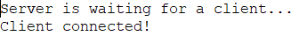
Start of Chat Application via Client
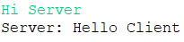
Start of Chat Application via Server
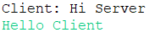
Small Conversation between them!
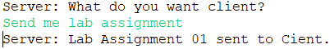
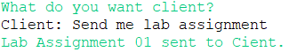

- Conclusion – In this assignment, I have studied and used Socket Programming principles and classes to create a simple chat interface between client and server.

